Scaling E-Commerce Architecture for Peak Events: A Black Friday Case Study
Prepared by: [Vaibhav Wadkar]
Date: 18 April 2025

Table of Contents
1. Executive Summary
2. Introduction
3. Objectives
4. Methodology
5. System Architecture & Overview
6. Traffic Analysis: Average vs. Peak Load
7. Authentication and Fallback Mechanisms
8. Content Delivery Networks (CDNs) and Alternatives
9. Data Storage and Scalability
10. Communication Protocols and Data Exchange
11. Staging Environment and Deployment Practices
12. Scalability and Resilience Strategies
13. Security Considerations
14. Potential Failures and Mitigation Strategies
15. Cost Optimization
16. Information exchanged
17. Conclusions

1. Executive Summary
This report examines the architectural strategies employed by e-commerce platforms to manage significant traffic surges during peak events, specifically focusing on Black Friday. It analyzes system components, traffic patterns, authentication mechanisms, content delivery methods, data storage solutions, and deployment practices. The report concludes with recommendations to enhance scalability, resilience, and user experience during high-demand periods.

2. Introduction
Black Friday represents one of the most challenging periods for e-commerce platforms, with traffic and transaction volumes increasing exponentially. Ensuring system reliability, performance, and security during such times is critical for maintaining customer trust and achieving business objectives.

3. Objectives
- Analyze the architectural components critical for handling peak traffic.
- Compare system behaviour under average and peak loads.
- Evaluate authentication strategies, including fallback mechanisms.
- Assess the role of CDNs and explore alternative solutions.
- Examine data storage scalability.
- Provide recommendations for improving system resilience and scalability.

4. Methodology
The analysis is based on industry best practices, case studies, and architectural patterns observed in high-traffic e-commerce platforms
5. System Architecture & Overview
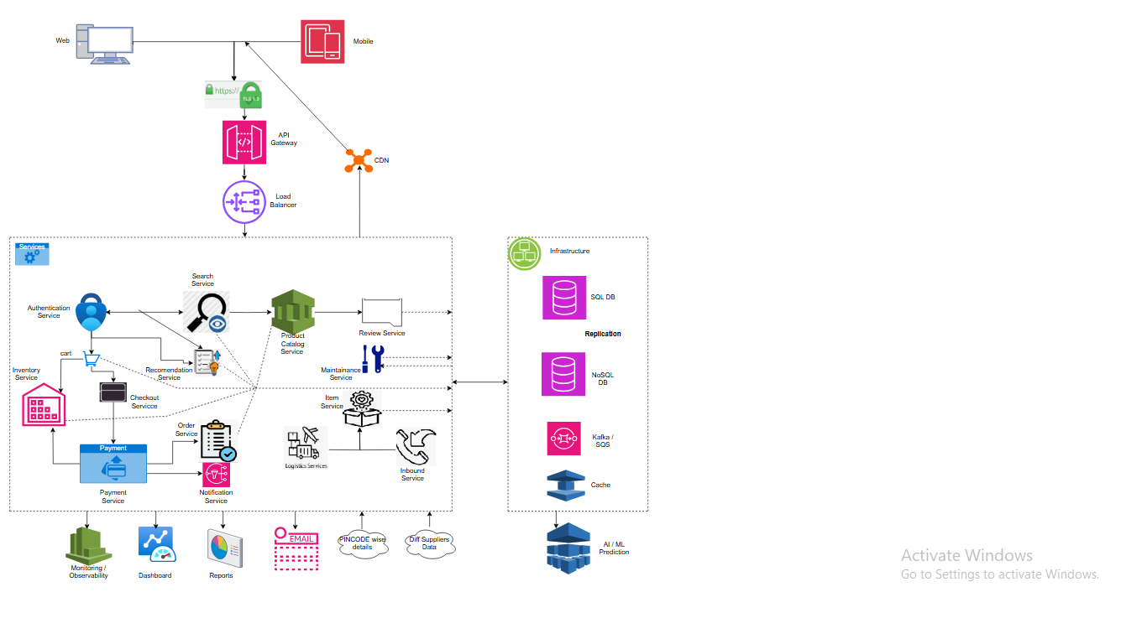
The architecture comprises:
- Client Interface: Web and mobile applications.
- API Gateway: Manages and routes incoming requests.
- Microservices: Modular services handling specific business functions.
- Databases: Combination of SQL and NoSQL databases.
- Caching Layer: Utilizes Redis or Memcached.
- Content Delivery Network (CDN): Distributes static content efficiently.
- Message Queues: Kafka or SQS or RabbitMQ for asynchronous communication.
- Monitoring Tools: Observability platforms for real-time insights.

6. Traffic Analysis: Average vs. Peak Load
Both average and peak loads is crucial for comprehensive traffic analysis. While average load analysis ensures efficient day-to-day operations, peak load analysis prepares the system to handle unexpected surges, ensuring reliability and user satisfaction during critical periods.
Metric | Average Load | Peak Load (Black Friday)
Concurrent Users | 50,000 | 250,000+
Requests per Second (RPS) | 5,000 | 25,000+
Transactions per Second | 500 | 5,000+
Data Throughput (Gbps) | 2 | 10+
Note: Metrics are indicative and may vary based on specific platform implementations.

7. Authentication and Fallback Mechanisms
- Primary Authentication: OAuth 2.0 with JWT tokens.
- Fallback Strategies:
  - Token caching at the API Gateway.
  - Graceful degradation to username/password authentication.
  - Temporary access tokens with limited scope.
These mechanisms ensure uninterrupted user access during authentication service outages.

8. Content Delivery Networks (CDNs) and Alternatives
- CDNs: Akamai, Cloudflare, and AWS CloudFront are commonly used to cache and deliver static content, reducing latency and server load.
- Alternatives:
  - Edge Computing: Deploying services closer to the user base.
  - Peer-to-Peer Content Distribution: Leveraging user devices for content sharing.
  - Regional Data Centers: Hosting content in geographically distributed servers.
Each alternative presents trade-offs in terms of complexity, cost, and performance.

9. Data Storage and Scalability
- Order Services: Utilize relational databases (e.g., PostgreSQL) for transactional integrity.
- Ledger Databases: Implemented using blockchain-inspired databases for immutable records.
- Scalability Strategies:
  - Database sharding.
  - Read replicas.
  - Horizontal scaling of NoSQL databases.
Ensuring data consistency and availability is paramount during high-load scenarios.

10. Communication Protocols and Data Exchange
- Inter-Service Communication: RESTful APIs and gRPC for synchronous calls.
- Asynchronous Messaging: Kafka or SQS or RabbitMQ handle event-driven communication.
- Data Exchange Metrics:
  - Message Size: Typically, 1–10 KB.
  - Frequency: Thousands of messages per second during peak.
  - Latency: Targeting sub-100ms for critical paths.
Efficient communication protocols are essential for system responsiveness.

11. Staging Environment and Deployment Practices
- Staging Environment: Mirrors production to test new features and updates.
- Deployment Practices:
  - Continuous Integration/Continuous Deployment (CI/CD) pipelines.
  - Canary deployments to minimize risk.
  - Automated rollback mechanisms in case of failures.
Regular testing in staging ensures stability and reliability in production.

12. Scalability and Resilience Strategies
- Auto-Scaling: Dynamically adjusts resources based on load.
- Load Balancing: Distributes traffic evenly across servers.
- Circuit Breakers: Prevent cascading failures.
- Graceful Degradation: Maintains core functionalities during partial outages.
These strategies enhance system robustness during unpredictable traffic spikes.

13. Security Considerations
- Data Protection: Encryption at rest and in transit.
- Access Control: Role-based access and multi-factor authentication.
- Compliance: Adherence to GDPR and other regional regulations.
- Monitoring: Real-time threat detection and incident response plans.
Security measures safeguard user data and maintain regulatory compliance.

14. Potential Failures and Mitigation Strategies
Mitigation strategies, ensuring a smoother experience for customers and minimizing potential losses.
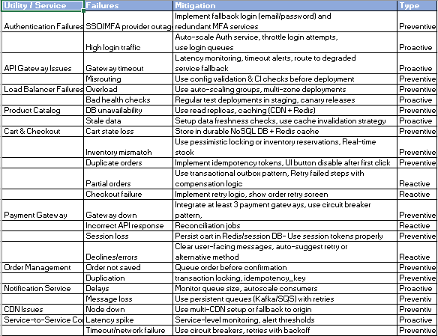

15. Cost Optimization
To ensure cost-effective scalability and resilience, the architecture leverages targeted tactics across key focus areas.
- High-traffic handling is optimized using CDN, caching, and asynchronous queues to reduce backend pressure.
- Payment systems use multi-gateway strategies with intelligent routing for higher success rates and fault tolerance.
- Compute resources scale dynamically with a mix of auto-scaling and serverless models, while storage costs are managed using tiered object storage and selective log sampling.
- The user experience layer incorporates graceful degradation to maintain core functionality even during partial failures.

16. Information exchanged (like frequency, speed, volume)
The system handles high-frequency transactions with ~10,000 TPS during peak events, including user interactions, product views, cart updates, and payments. Data volume is significant, with millions of reads/writes per day across services like catalog, user, and order systems. Speed is critical, demanding low-latency responses (<200ms) for seamless user experience across web and mobile platforms.
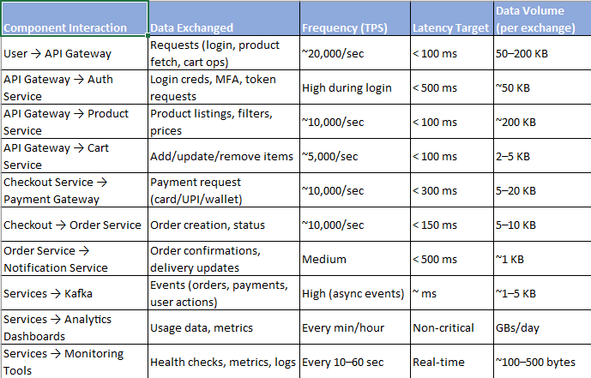

17. Conclusions
E-commerce platforms must adopt robust architectural strategies to handle the demands of peak events like Black Friday. By implementing scalable, resilient, and secure systems, businesses can ensure seamless user experiences and maintain operational integrity.

